■ Answers to Textbook Problems
- A reduction in the home money demand causes interest rates in the home country to fall from Rh,l to Rh,2. With no change in expectations, there will be a depreciation of the home currency from El to E2 as investors shift their savings into higher-interest-paying foreign assets.
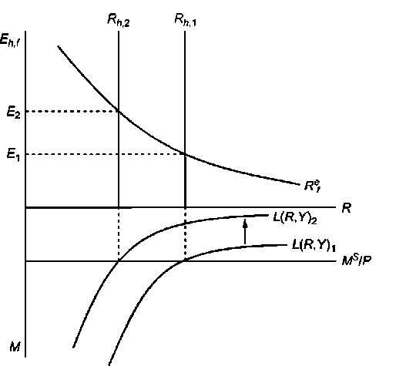
In the long run, increased spending on home products (through lower interest rates and a depreciated currency) will cause prices in the home country to rise. This will shift the real money supply inward to a point where home interest rates return to their original level R_{h,1} and the exchange rate falls back to E₁.
- A fall in a country’s population would reduce money demand, all else being equal, because a smaller population would undertake fewer transactions and thus demand less money. This effect would probably be more pronounced if the fall in the population were due to a fall in the number of households rather than a fall in the average size of a household because a fall in the average size of households implies a population decline due to fewer children who have relatively small transactions demand for money compared to adults. The effect on the aggregate money demand function depends upon no change in income commensurate with the change in population—else, the change in income would serve as a proxy for the change in population with no effect on the aggregate money demand function.
- Equation 15-4 is M^{S} /P = L(R, Y). The velocity of money, V = Y/(M/P). Thus, when there is equilibrium in the money market such that money demand equals money supply, V = Y/L(R, Y). When R increases, L(R, Y) falls and thus velocity rises. When Y increases, L(R, Y) rises by a smaller

amount (because the elasticity of aggregate money demand with respect to real output is less than one), and the fraction Y/L(R, Y) rises. Thus, velocity rises with either an increase in the interest rate or an increase in income. Because an increase in interest rates as well as an increase in income causes the exchange rate to appreciate, an increase in velocity is associated with an appreciation of the exchange rate.
- An increase in domestic real GNP will cause domestic real money demand to rise. This will cause domestic real interest rates to rise from Rh,l to Rh,2 (see graph below). With no change in expectations, there will be an appreciation of the home currency from E1 to E2 as investors channel their savings into domestic assets.
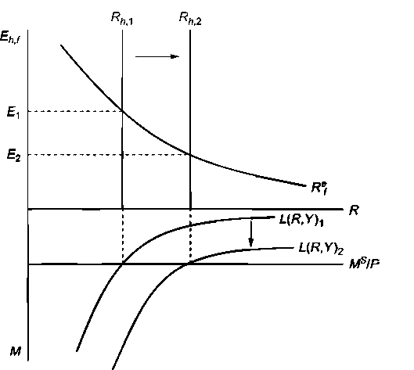
- Just as money simplifies economic calculations within a country, use of a vehicle currency for international transactions reduces calculation costs. More importantly, the more currencies used in trade, the closer the trade becomes to barter because someone who receives payment in a currency she does not need must then sell it for a currency she needs. This process is much less costly when there is a ready market in which any nonvehicle currency can be traded against the vehicle currency, which then fulfills the role of a generally accepted medium of exchange.
- Currency reforms are often instituted in conjunction with other policies that attempt to bring down the rate of inflation. There may be a psychological effect of introducing a new currency at the moment of an economic policy regime change, an effect that allows governments to begin with a “clean slate” and makes people reconsider their expectations concerning inflation. Experience shows, however, that such psychological effects cannot make a stabilization plan succeed if it is not backed up by concrete policies to reduce monetary growth.

- a. As we would expect, the price level rises consistently with the increase in the Ghana money supply. The long-run price level is defined as P = MS/L(R,Y), so an increase in the money supply should cause prices to rise. An increase in the money supply and the price level should in turn cause the Ghana cedi to depreciate against the dollar. The relationship with the exchange rate is not so straightforward in the short run, but if we consider the medium and long run evolution the relationship stands.
(See Key Determinants of Inflation in Ghana Amos Oppong and alli, British Journal of Economics, Management & Trade, 2015,
http://www.joumalrepository.org/media/joumals/BJEMT_20/2015/Jun/Quaye832015BJEMT1802 4.pdf)
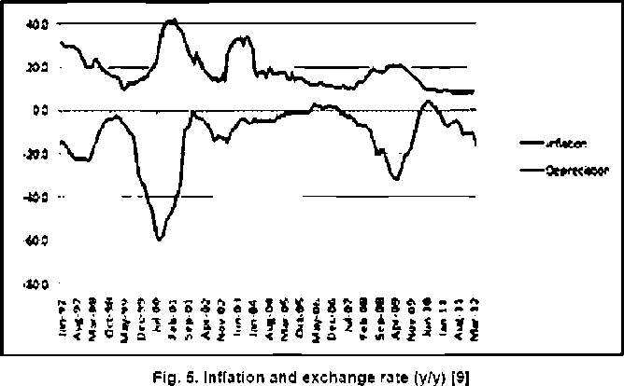
- From 1994 to 1996, the inflation increases by 130%, the money growth around the same percentage (135%) and the cedi devaluate of 70%. A recent study (Exchange Rate Pass-Through in Ghana Siaw Frimpong, Anokye M. Adam, International Business Research Vol. 3, No. 2; April 2010 - hiip://citeseerx.ist.psu.edu/viewdoc/download?doi=10.1.1.666.8044&rep=repl&type=pdf) finds an incomplete and decreasing exchange rate pass-through to inflation in the short run in Ghana, consistent with findings on other African countries, but with few explanations.
- The same study shows the relationship between crude oil price and election impact: “The findings indicate a positive relationship between crude oil price at the world market and inflation, Cedi- Dollar exchange rate and inflation as well as Elections and inflation. Each of the determinants: crude oil price, exchange rate and ESQE is statistically significant at 1%. »

The impact of increase of crude oil price to Ghana inflation results from the pass trough of import price on internal price which is all the more important that Ghana is heavily dependent on imported crude oil to meet her energy needs.
The election impact derives from the Political Business Cycle (PBC) theory which argues that during the periods before and after the election, the economic policy is oriented toward expenses more than toward strict economic equilibrium.
{source of the board: GDP GROWTH, MONEY GROWTH, EXCHANGE RATE AND INFLATION IN GHANA , ANTHONY CHIARAAH& PAUL KWAME NKEGBE Journal of Contemporary Issues in Business Research Volume 3, Issue No. 2, 2014,
hiip://citeseerx. ist.psu. edu/viewdoc/download?doi =10.1.1.680.6400&rep=repl&type =pdj)
- The chart below gives inflation rates since 1980 for New Zealand, Chile, Canada, and Israel:
In every case (as well as for those countries not included in the chart above), inflation is significantly more stable after the adoption of inflation targeting.
- If an increase in the money supply induces an increase in real output in the short run, then the short-run decrease in the real interest rate will not be as pronounced as it was without the increase in real output. In the diagram below, the money supply rises from Ms.,1 to Ms.,2. This causes real output to rise from Y1 to Y2 and shifts the real money demand curve out from L(R, Yl) to L(R, Y2). In the diagram below, the resulting shifts lead to a reduction in interest rates from Rh,l to Rh,2, which is a smaller drop in interest rates than would have prevailed had real money demand not shifted. (Note that it is possible that interest rates could have actually increased if the increase in real money demand was proportionately larger than the increase in nominal money supply. In this case, we will get exchange rate undershooting, with the short-run exchange rate below its long-run level.) Turning to the exchange rate diagram, two events occur. First, the drop in interest rates shifts the return on home assets from Rh,1 to Rh,2. Second, there is a change in expectations as people anticipate that the home currency will depreciate when home prices rise in the future.

This shifts the expected return on foreign assets from R^{e}_{f,1} to R^{e}_{f,2} . As a result of these shifts, the home currency depreciates from E1 to E2. However, the drop in the value of the home currency is not as severe as it would have been had output not increased (thus limiting the decrease in interest rates).

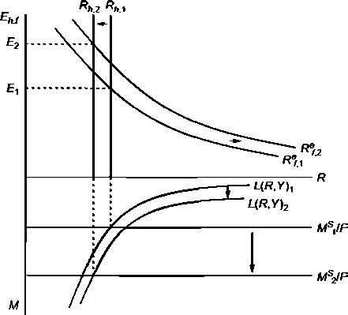
In the long run, prices in the home country will rise, shifting real money supply back to its original level and according to the text of the question, dropping output back to Y₁. This will cause interest rates to rise and, with no change in the expected return on foreign assets, cause the exchange rate to settle in at some value between E₁ and E₂. The extent of exchange rate overshooting is smaller in this scenario than when changes in the money supply have no effect on output because the change in output limits how large of an impact monetary policy has on real interest rates.
- As the interest rate falls, people prefer to hold more cash and fewer financial assets. If interest rates were to fall below zero, people would strictly prefer cash to financial assets as the zero return on cash would dominate any negative return. Thus, interest rates cannot fall below zero because no one would hold a financial asset with a negative rate of return when another asset at a zero rate of return (cash) exists.
- One clear complication that a zero interest rate introduces is that the central bank is “out of ammunition.” It literally cannot reduce interest rates any further and thus may struggle to respond to additional shocks that hit the economy over time. The central bank is still not completely powerless; it can print more money and try to increase inflation (increasing inflation with a constant zero interest rate would mean a declining real interest rate) to stimulate the economy, but the standard toolkit is not operational. As further discussion in Chapter 17 will show, a zero interest rate may also be a symptom of a lack of responsiveness in the economy to low interest rates.
- a. If money adjusts automatically to changes in the price level, then any number of combinations of
money and prices could satisfy the money supply/money demand equations. There would be no unique solution.

- Yes, a rule such as this one would help anchor the price level and imply there is no longer an infinite number of money and price combinations that could satisfy money supply and money demand.
- A one-time permanent unexpected fall in "u" would imply that R would have to fall until prices have a chance to rise and balance out the equation. As prices rise, R would return to its initial level. The story described is essentially identical to that in Figure 15-13. The interest rate would drop and then rise slowly over time, and the price level would start out static and then rise over time. The exchange rate should overshoot (assuming that expectations are tied to future prices in the same way they are described in the text).
- Students should refer to - hiips://www.imf.org/external/pubs/ft/weo/2016/02/weodata/index.aspx. The CFA Zone have had much lower inflation than the Sub-Saharan countries as a group (less than 2% against more than 8%) and especially against floats or intermediate regimes. Economic policy models suggest that pegged exchange rates should be associated with lower inflation because they instill monetary discipline (implying a lower rate of money growth) and engender confidence in the currency (implying lower inflation expectations, higher money demand, and therefore lower inflation for a given rate of money growth. {IMF Regional economic outlook. Sub-Saharan Africa, Oct 2016, hiips://www. imf.org/external/pubs/ft/reo/2016/afr/eng/sreol016.htm).
Figure S 3 Selected Samples: Inflation Performance
1. Emerg i n g Marital and Develop irg Economies 2. Sub-Sahara n Africa
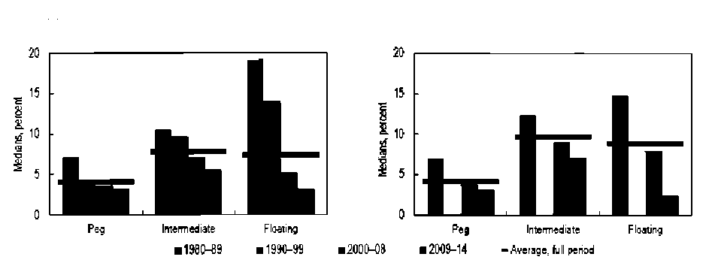

© 2018 Pearson Education Ltd.
